**Introduction to Computers and Information Systems**

**Final Exam Study Guide**

1. Computer Guts

a. Von Neumann architecture

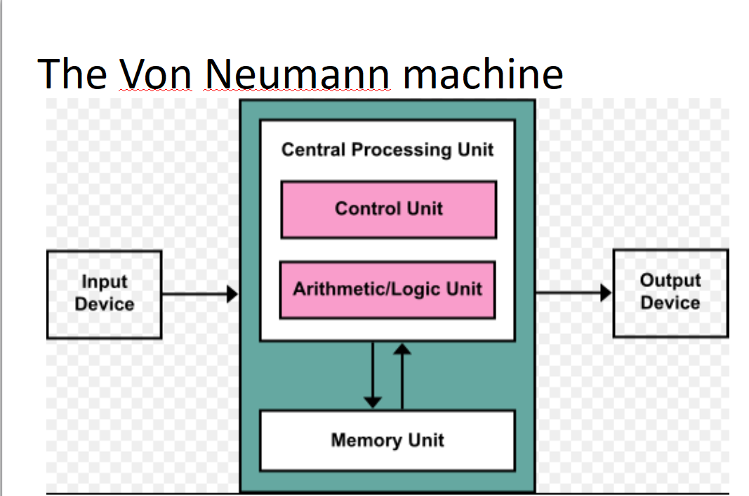

**The Von Neumann machine**

* Based on Alan Turing’s hypotheses from the 1930s.
* The earliest computing devices could not be programmed. Use was like an old-fashioned operator switchboard.
* The core of V.N.’s idea was shared memory for both instructions and data.
* The Central Processing Unit reads an instruction, moves data, and performs the requested operation

**The Von Neumann machine - input**

* Punched cards
* Magnetic tape
* Keyboard
* Telemetry

**The Von Neumann machine - output**

* Printer
* Magnetic Tape
* Indicator Lights
* Screen

**The Von Neumann machine – I/O**

* Magnetic Tape
* Magnetic (Hard) Disk
* Terminal / Modem

**The Von Neumann machine – internal memory**

* ROM (Read Only Memory)
* RAM (Random Access Memory)
* EEPROM (Electrically Erasable Programmable Read Only Memory)

Volatile & Non-volatile

**The Von Neumann machine – CPU**

* Control Unit
* Arithmetic Logic Unit
* Processing Registers

b. Moore’s Law

Moore’s Law

“The complexity for minimum component

costs has increased at a rate of roughly a

factor of two per year. Certainly over the

short term this rate can be expected to

continue, if not to increase. Over the longer

term, the rate of increase is a bit more

uncertain, although there is no reason to

believe it will not remain nearly constant for

at least 10 years.”

- Gordon E. Moore, April 1965 Electronics Magazine

**Gordon Moore** was director of R&D at

Fairchild Semiconductor when he was asked

to pen his projections for the next 10 years.

* This trend has been consistent since 1965,

but began to slow in 2016.

**c. Types of memory and storage**

**Volatile and Nonvolatile**

2. Notable Figures

-Blaise Pascal

-French mathematician

-Jansenist theologian

-Physicist, particularly hydrodynamics

-Philosopher

-First digital calculator, forming the basis

for the *accumulator*, a critical circuit in

every computer processor.

-Gottfried Wilhelm Leibniz

-GeGottfried Wilhelm Leibniz

-German polymath, particularly symbolic

Logic.

-Philosopher

-Inventor

-Lawyer

-German polymath, particularly symbolic logic.

-Philosopher

-Inventor

-Innovated on Pascal’s calculator to include

all four primary operations. Also responsible

for differential calculus.

-Charles Xavier Thomas de Colmar

-19th century French businessman

-Contribution to Computer Science:

Patented the Arithmemetre in 1820, the

first commercially successful mechanical

calculator. Based on Leibniz’s design, it

was still being used

dependably through WWI.

-Joseph Marie Jacquard

-18th century French master weaver

-Primary motivation was to reduce the

cost of weaving patterned

fabrics

-Contribution to Computer Science:

Adapted other contemporary

inventions to create a

*peripheral input device*,

allowing reliable repetition

of a given pattern.

-Charles Babbage

-English mathematician and philosopher.

-Hated the error-prone processes of manually calculating math(logarithmic and polynomial) tables.

-Combined Jacquard’s punched card system with Leibniz’s calculator to design the world’s first programmable computing machine, the *Analytical Engine*. It was

never actually produced.

a. Review the matching section from exam #1.

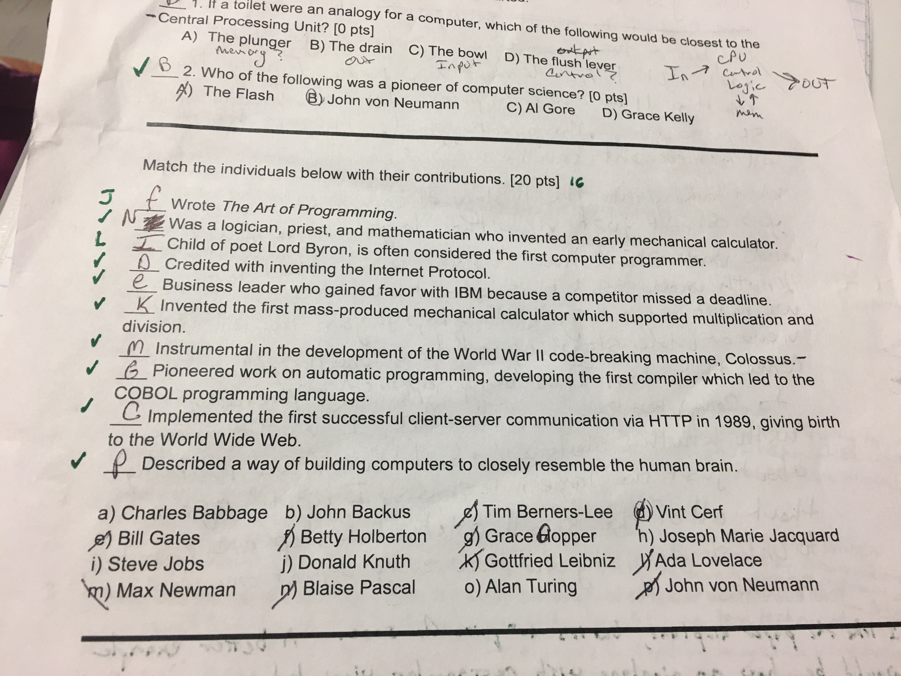

**3. Powers of 2**

**a. *Memorize* the powers of 2 from 0 to 16.**

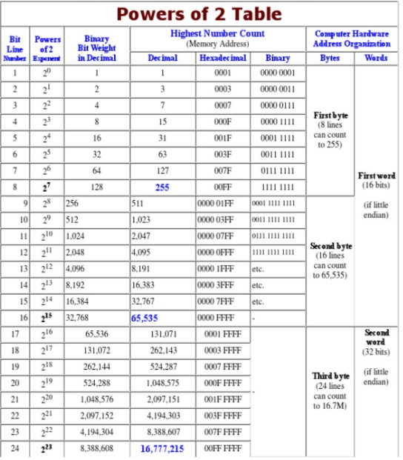

**b. Know how to calculate a decimal number from binary or hexadecimal (there won’t be any marathon questions on this, I promise).**

We will practice this as we study not included on this page.

**4. Networking**

**a. The difference between TCP and UDP.**

TCP= The Transmission Control Protocol (TCP) is one of the main protocols of the Internet protocol suite. It originated in the initial network implementation in which it complemented the Internet Protocol (IP). Therefore, the entire suite is commonly referred to as TCP/IP

UDP= User Datagram Protocol (UDP) is part of the Internet Protocol suite used by programs running on different computers on a network. UDP is used to send short messages called datagrams but overall, it is an unreliable, connectionless protocol. UDP is officially defined in RFC 768 and was formulated by David P. Reed

**b. The meaning of MAC address, IP address, and subnet.**

**MAC address=** A media access control address (MAC address) of a device is a unique identifier assigned to network interfaces for communications at the data link layer of a network segment. MAC addresses are used as a network address for most IEEE 802 network technologies, including Ethernet and Wi-Fi.

**IP Address**= a unique string of numbers separated by periods that identifies each computer using the Internet Protocol to communicate over a network

**Subnet**= A subnet (short for "subnetwork") is an identifiably separate part of an organization's network. Typically, a subnet may represent all the machines at one geographic location, in one building, or on the same local area network (LAN). Having an organization's network divided into subnets allows it to be connected to the Internet with a single shared network address. Without subnets, an organization could get multiple connections to the Internet, one for each of its physically separate subnetworks, but this would require an unnecessary use of the limited number of network numbers the Internet has to assign. It would also require that Internet routing tables on gateways outside the organization would need to know about and have to manage routing that could and should be handled within an organization.

**c. The use of ports 25, 80, and 443.**

25 - SMTP

80 - HTTP

443 - HTTPS

**d. The difference between hub, switch, router, and firewall**.

**Hub**= When referring to a network, a hub is the most basic networking device that connects multiple computers or other network devices together. Unlike a network switch or router, a network hub has no routing tables or intelligence on where to send information and broadcasts all network data across each connection

**Switch=** A network switch (also called switching hub, bridging hub, officially MAC bridge) is a computer networking device that connects devices together on a computer network by using packet switching to receive, process, and forward data to the destination device.

**Router=** A router is a networking device that forwards data packets between computer networks. Routers perform the traffic directing functions on the Internet. A data packet is typically forwarded from one router to another router through the networks that constitute an internetwork until it reaches its destination node.

**Firewall=** A firewall is a system designed to prevent unauthorized access to or from a private network. You can implement a firewall in either hardware or software form, or a combination of both. Firewalls prevent unauthorized Internet users from accessing private networks connected to the Internet, especially intranets

**5. Open Source Software**

**a. The meaning of “free” in free software.**

**Why Open Source Misses the Point**

**of Free Software (rms):**

https://www.gnu.org/philosophy/open-source-misses-the-point.html

•All free software is open source.

•Not all open source is free.

•Some platforms refuse to run

unofficial versions of binary

programs (i.e., Tivo).

•Some programs forbid copying.

**Open Source Foundations**:

•Apache

•Mozilla

•OpenStack

**Open Source Foundations: Apache**

•More than just a web server.

•Includes

•Java libraries

•Hadoop database engine

•Fonts and rendering

•Machine learning

**Open Source Foundations: Mozilla**

•More than just a web browser.

•Includes

•Virtual Reality over the WWW

•WebAssembly and WebGL

•Rust programming language

•Lean Data

•Education

•Advocacy

**Open Source Foundations: OpenStack**

•Software that makes “The Cloud”.

•Includes components for

•Distributed computing

•Distributed storage and network

•Data and analytics

•Identity and Security

•Monitoring and Metering

**Open Source Foundations: Others**

•There are a lot of other foundations

which target a single product suite.

•Eclipse

•OpenCV

•Document Foundation

**b. The history of UNIX, CP/M, DOS, MacOS, and Linux.**

**Operating Platform-**

a software on the hard drive that enables the computer hardware to communicate and operate with the computer software

**Multics History**

The system began as a joint project between MIT’s Project MAC, BEll Telephone Laboratories, and General Electric Company’s Large Computer Products Division

Bell Labs withdrew in 1969 and in 1970 GE sold its computer business to Honeywell

Honeywell the offered Multics as a commercial product and sold systems until 1985 when it was cancelled, however, Multics survived and was used until 2000.

The initial goal was simply controlled sharing of information but grew and expanded with the influence of controlled sharing into the areas of user authentication, inter-user isolation, supervisor-user protection, user-written proprietary programs, and control of special privileges

**Unix History**

When Bell Labs, otherwise known as AT&T, decided to withdrawal from the development of multics in 1969, they developed and started UNICS or UNiplexed Information and Computing Service

They developed the first versions of Unix on the PDP-7

The V6 version in 1975 was the first to become available outside of Bell Labs and Berkley University formed the basis for Unix.

Berkeley students had developed the Berkeley Standard Distribution or BSD based off of the version of that was released from Bell Labs.

In the 1990’s, the source code licensing had a thriving market and there were hundreds of Unix variants by different manufacturers, however, this controlling Market convinced Richard Stallman that there needed to be a free operating system that anyone could use.

He then developed the clone known as GNU.

it had reached a point of being complete except for one component, a working kernel. Thus, leading to the creation of Linux.

**History of Linux**

Linux is the combination of the GNU and a free kernel created by Linus Torvalds in 1991.

By 1994, people could pair the two together and have a completely free operating system .

Linux runs on several differing chip architectures and has been easily adopted to various extents.

Hewlett-Packard, Silicon Graphics, Sun Microsystems, Compaq, Dell, Oracle, and IBM have all adopted or supported the Linux system in some capacity.

Today, Linux is still quite popular and is widely used. This is due simply to the fact that it works well and that it is free to use and that it is easy to build, improve, and explore since the source code is available and there is a whole community of support behind it.

Comparison Factors

The advancement of technology, with new capabilities and desired functions leads to the rise and fall of Operating Platforms, if they are developed along side they will survive and thrive, if not fall out of popularity and fade out of popular use.

The development of Multics was cancelled in 1985, meaning development stopped and therefore, it could not be used widely after a certain point.

Unix was developed until it reached a point where it become unfavorable to purchase and operating system when you could get one for free.

Linux then upon interest shifting into different forms of technologies like, mobile phones video game consoles, as well as mainframes and supercomputers

Audience and Functionality

Multics is a sustaining technology or one that listened to their customers and building the technology with that focus.

However, with Multics the hardware was was expensive, it required lots of resources, and was targeted towards a small group of people. They aimed for a commercial audience

completed a system that consumers asked them too but their customer base was small and limited

Unix was a disruptive technology, meaning that is was targeted to a different group of people that value the technology with a different perspective (whether or not it is well made).

In this case it was targeted to the users of the inexpensive mini computer users, who were interested in a platform for programming and experimentation.

It had modest goals, ran on modest hardware and was freely shared. Unix received positive feedback from customers and began to work on better, more powerful, and cost effective hardware

Therefore, generating a wider and developed more potential in their customer base than Multics did, allowing for faster growth as well

Linux is an open source, or free to use operating system, that can be used on different types of devices. These devices include computer hardware and software, game development, tablet PCS, and Mainframes

open source development or the sharing and collaboration of code and features through forums and can be distributed by varying vendors

Marketed towards home users, developers, and computer enthusiasts.

**CP/M,** originally standing for Control Program/Monitor and later Control Program for Microcomputers,[3][4][5] is a mass-market operating system created for Intel 8080/85-based microcomputers by Gary Kildall of Digital Research, Inc. Initially confined to single-tasking on 8-bit processors and no more than 64 kilobytes of memory, later versions of CP/M added multi-user variations and were migrated to 16-bit processors.

The combination of CP/M and S-100 bus computers was loosely patterned on the MITS Altair, an early standard in the microcomputer industry. This computer platform was widely used in business through the late 1970s and into the mid-1980s.[6] CP/M increased the market size for both hardware and software by greatly reducing the amount of programming required to install an application on a new manufacturer's computer.[7][8] An important driver of software innovation was the advent of (comparatively) low-cost microcomputers running CP/M, as independent programmers and hackers bought them and shared their creations in user groups.[9] CP/M was displaced by MS-DOS soon after the 1981 introduction of the IBM PC.

**DOS**- MS-DOS (Microsoft Disk Operating System) is a single-user, single-tasking computer operating system that uses a command line interface. In spite of its very small size and relative simplicity, it is one of the most successful operating systems that has been developed to date.

When IBM launched its revolutionary personal computer, the IBM PC, in August 1981, it came complete with a 16-bit operating system from Microsoft, MS-DOS 1.0. This was Microsoft's first operating system, and it also became the first widely used operating system for the IBM PC and its clones.

MS-DOS 1.0 was actually a renamed version of QDOS (Quick and Dirty Operating System), which Microsoft bought from a Seattle company, appropriately named Seattle Computer Products, in July 1981. QDOS had been developed as a clone of the CP/M eight-bit operating system in order to provide compatibility with the popular business applications of the day such as WordStar and dBase. CP/M (Control Program for Microcomputers) was written by Gary Kildall of Digital Research several years earlier and had become the first operating system for microcomputers in general use.

QDOS was written by Tim Paterson, a Seattle Computer Products employee, for the new Intel 16-bit 8086 CPU (central processing unit), and the first version was shipped in August, 1980. Although it was completed in a mere six weeks, QDOS was sufficiently different from CP/M to be considered legal. Paterson was later hired by Microsoft.

Microsoft initially kept the IBM deal a secret from Seattle Computer Products. And in what was to become another extremely fortuitous move, Bill Gates, the not uncontroversial co-founder of Microsoft, persuaded IBM to let his company retain marketing rights for the operating system separately from the IBM PC project. Microsoft renamed it PC-DOS (the IBM version) and MS-DOS (the Microsoft version). The two versions were initially nearly identical, but they eventually diverged.

**MACOS-** The family of Macintosh operating systems developed by Apple Inc. includes the graphical user interface-based operating systems it has designed for use with its Macintosh series of personal computers since 1984, as well as the related system software it once created for compatible third-party systems.

In 1984, Apple debuted the operating system that is now known as the "Classic" Mac OS with its release of the original Macintosh System Software. The system, rebranded "Mac OS" in 1996, was preinstalled on every Macintosh until 2002 and offered on Macintosh clones for a short time in the 1990s. Noted for its ease of use, it was also criticized for its lack of modern technologies compared to its competitors.[1][2]

The current Mac operating system is macOS, originally named "Mac OS X" until 2012 and then "OS X" until 2016.[3] Developed between 1997 and 2001 after Apple's purchase of NeXT, Mac OS X brought an entirely new architecture based on NeXTSTEP, a Unix system, that eliminated many of the technical challenges that faced the classic Mac OS. The current macOS is preinstalled with every Mac and is updated annually.[4] It is the basis of Apple's current system software for its other devices, iOS, watchOS, and tvOS.[5]

Prior to the introduction of Mac OS X, Apple experimented with several other concepts, releasing different products designed to bring the Macintosh interface or applications to Unix-like systems or vice versa, A/UX, MAE, and MkLinux. Apple's effort to expand upon and develop a replacement for its classic Mac OS in the 1990s led to a few cancelled projects, code named Star Trek, Taligent, and Copland.

Although they have different architectures, the Macintosh operating systems share a common set of GUI principles, including a menu bar across the top of the screen; the Finder shell, featuring a desktop metaphor that represents files and applications using icons and relates concepts like directories and file deletion to real-world objects like folders and a trash can; and overlapping windows for multitasking.

**c. Simple regular expressions.**

Metacharacters Defined

MChar Definition

^ Start of a string.

$ End of a string.

. Any character (except \n newline)

| Alternation.

{...} Explicit quantifier notation.

[...] Explicit set of characters to match.

(...) Logical grouping of part of an expression.

* 0 or more of previous expression.

+ 1 or more of previous expression.

? 0 or 1 of previous expression; also forces minimal matching when an expression might match several strings within a search string.

\ Preceding one of the above, it makes it a literal instead of a special character. Preceding a special matching character, see below.

Metacharacter Examples

Pattern Sample Matches

^abc abc, abcdefg, abc123, ...

abc$ abc, endsinabc, 123abc, ...

a.c abc, aac, acc, adc, aec, ...

bill|ted ted, bill

ab{2}c abbc

a[bB]c abc, aBc

(abc){2} abcabc

ab*c ac, abc, abbc, abbbc, ...

ab+c abc, abbc, abbbc, ...

ab?c ac, abc

a\sc a c

Character Escapes http://tinyurl.com/5wm3wl

Escaped Char Description

ordinary characters Characters other than . $ ^ { [ ( | ) ] } * + ? \ match themselves.

\a Matches a bell (alarm) \u0007.

\b Matches a backspace \u0008 if in a []; otherwise matches a word boundary (between \w and \W characters).

\t Matches a tab \u0009.

\r Matches a carriage return \u000D.

\v Matches a vertical tab \u000B.

\f Matches a form feed \u000C.

\n Matches a new line \u000A.

\e Matches an escape \u001B.

\040 Matches an ASCII character as octal (up to three digits); numbers with no leading zero are backreferences if they have only one digit or if they correspond to a capturing group number. (For more information, see Backreferences.) For example, the character \040 represents a space.

\x20 Matches an ASCII character using hexadecimal representation (exactly two digits).

\cC Matches an ASCII control character; for example \cC is control-C.

\u0020 Matches a Unicode character using a hexadecimal representation (exactly four digits).

\* When followed by a character that is not recognized as an escaped character, matches that character. For example, \* is the same as \x2A.

Character Classes http://tinyurl.com/5ck4ll

Char Class Description

. Matches any character except \n. If modified by the Singleline option, a period character matches any character. For more information, see Regular Expression Options.

[aeiou] Matches any single character included in the specified set of characters.

[^aeiou] Matches any single character not in the specified set of characters.

[0-9a-fA-F] Use of a hyphen (–) allows specification of contiguous character ranges.

\p{name} Matches any character in the named character class specified by {name}. Supported names are Unicode groups and block ranges. For example, Ll, Nd, Z, IsGreek, IsBoxDrawing.

\P{name} Matches text not included in groups and block ranges specified in {name}.

\w Matches any word character. Equivalent to the Unicode character categories [\p{Ll}\p{Lu}\p{Lt}\p{Lo}\p{Nd}\p{Pc}]. If ECMAScript-compliant behavior is specified with the ECMAScript option, \w is equivalent to [a-zA-Z_0-9].

\W Matches any nonword character. Equivalent to the Unicode categories [^\p{Ll}\p{Lu}\p{Lt}\p{Lo}\p{Nd}\p{Pc}]. If ECMAScript-compliant behavior is specified with the ECMAScript option, \W is equivalent to [^a-zA-Z_0-9].

\s Matches any white-space character. Equivalent to the Unicode character categories [\f\n\r\t\v\x85\p{Z}]. If ECMAScript-compliant behavior is specified with the ECMAScript option, \s is equivalent to [ \f\n\r\t\v].

\S Matches any non-white-space character. Equivalent to the Unicode character categories [^\f\n\r\t\v\x85\p{Z}]. If ECMAScript-compliant behavior is specified with the ECMAScript option, \S is equivalent to [^ \f\n\r\t\v].

\d Matches any decimal digit. Equivalent to \p{Nd} for Unicode and [0-9] for non-Unicode, ECMAScript behavior.

\D Matches any nondigit. Equivalent to \P{Nd} for Unicode and [^0-9] for non-Unicode, ECMAScript behavior.

**6. Software Licensing**

a.  **The difference between copyright and patent.**

**The difference between patents and copyright**

* Copyright is a form of protection provided to the authors of “original works of authorship” including literary, dramatic, musical, artistic, and certain other intellectual works, both published and unpublished.
* The copyright protects the form of expression rather than the subject matter of the writing.
* What is granted [by a patent] is not the right to make, use, offer for sale, sell or import, but the right to exclude others from making, using, offering for sale, selling or importing the invention.

b. **The function of a software license.**

**What’s in a software license?**

•A description of the owner.

•A limit of liability.

•Permission to use, conditionally.

•Restrictions on copying and modifying.

•Legal jurisdiction.

Example: Adobe Acrobat X Pro (from p.96)

http://wwwimages.adobe.com/content/dam/acom/en/legal/licenses-terms/pdf/CS6.pdf

**Permission to copy:**

**Copyleft** – you may copy, but all copies must also include the right to copy.

Permissive – you may copy, but the copies may be restricted.

License management software:

Most vendors and VARs have their own license management tools as well.

**Ways to license proprietary software:**

•User

•Device

•Site

•Instance

•CPU Core

•Perpetual

•Annual

•Cloud

**c. The pros and cons of the GNU Public License.**

**Pros:**

**People are allowed to copy the software for their own software and products.**

**Cons:**

**Because of the license if the GNU coding is used it needs to be open source which makes it hard for people creating a projects to sell to make a profit unless it is based off selling support. However Since its open source others can come and sell support for it and leach of the creators work while possibly giving the product and company a bad name.**

**d. The need for corporate software license management.**

**There needs to be corporate software license management to make sure that the company has enough license to run the software that they have. On top of this there is also the fact that a company can have a lot of extra Licenses to which they would be able to sell and make a some money back.**

**7. Cybersecurity**

**a. The rule of 3.**

**The principle of 3:**

- If your data does not exist in at least 3

places, it does not exist at all.

In groups, brainstorm ideas on how to

protect simple file data.

1) needs to be in a separate physical location in order to insure preservation.

2) Cloud storage

3) Drive or Server On-site

Automatic O/S backup:

Windows Volume Shadow Service (VSS)- gives extra copy on a different drive

Novell Storage Service (NSS)- keeps record of previous record before changes (keeps everything)

**Tape backup:**

- DDS/DAT – inexpensive for small volumes

requiring long-term archival.

https://support.hpe.com/hpsc/doc/public/display?docId=emr_na-lpg50457

- LTO – can store up to 32TB (base 10)

per tape, compressed. Often used in

large tape libraries of dozens of tapes.

http://www.maximummidrange.com/blog/lto-tape-comparison-charts/1883

**Network attached storage (NAS):**

(NetApp)

- Mirrors block level changes of storage

arrays, allowing point-in-time

bare-metal restores of entire systems

in minutes. Much more expensive than

Tape.(a complete mirror, but a portion at the block level) (can recreate an entire server and recreate it in minutes)

**Snapshot:**

- Within a Storage Area Network (SAN)(Cloud)(have not really moved the data elsewhere, but it solves the corruption risk),

point-in-time backups are made of the

entire volume in another part of the

SAN. This allows immediate recovery

as long as the hardware is intact.

**Log-shipping:**

-Typically used in databases, transaction

logs are copied to remote instances of

the same database, so all the data

exists in multiple places, with some time

delay for synchronization.

Provides Global coverage, and can be accessed instantaneously globally(delay is acceptable)

Can assign master and master data triumphs over all

Disaster Recover services:

(Iron Mountain, Sunguard)

- Will take drives, tapes, and/or NAS

devices to a secure location to get

operations running within a contracted

time in the event the data center

becomes unusable.

**Servers ready to go. Backup tapes. Separate physical location to recover data Tapes.**

**b. Types of cyber attacks.**

**Methods of Cyberattack;**

Operating system and application exploits

Phishing- using social engineering to pretend to be something it's not and have users provide information voluntarily (Fake Website).

SQL injection- form on a web page with special characters that will take the form data that will generate a database, and the cracker can access that database.

Cross Site scripting (XSS)- many browsers protect against this, however, it still happens. Users of the website, are unaware of what they are installing or using. Bitcoin Mining or CryptoCurrency is becoming popular, they steal bandwidth, electricity, computer speed/ function.

Physical access- direct access to the servers or database, wired into database, penetrated the system and gained all information needed to get full access.

Man in the middle- open wifi, or low level encryption, use a packet sniffer/monitoring, to view what other people are doing, (no permission= Illegal) (however, legal if for an occupation)

DDOS(Distributed Denial of Service)/Spam DOS, including RF jamming- (Slashdotting Webpage)( If intentional then illegal)

Electromagnetic Pulse (EMP)- nuclear event, solar flare, last solar flare in 1800’s. If it happened today we would have go dark for a week to 4 years. If one transistor blew, we only have on backup in the country. Without the transistors, if one blew without having enough backups, half the country could have no electricity for 4 years.

**c. The main reasons for cyberattacks.**

**Purposes of Cyberattacks;**

* Financial gain or identity theft
* Corporate espionage
* National Terrorism
* Political or personal statement
* Thuggery or vandalism

**d. Basic security practices.**

**Have a disaster recovery plan i.e. offering from Amazon, microsoft, and rackspace**

**Rule of three: Have a minimum of three separate backups preferably in different locations. (Tape backup, NAS, snapshot, log-shipping etc.)**

**8. Corporate History**

**a. The reasons for Yahoo!’s failure.**

1. Value confusion

2. Forfeit of original purpose

3. Online security

**b. Review the matching section on exam #3.**

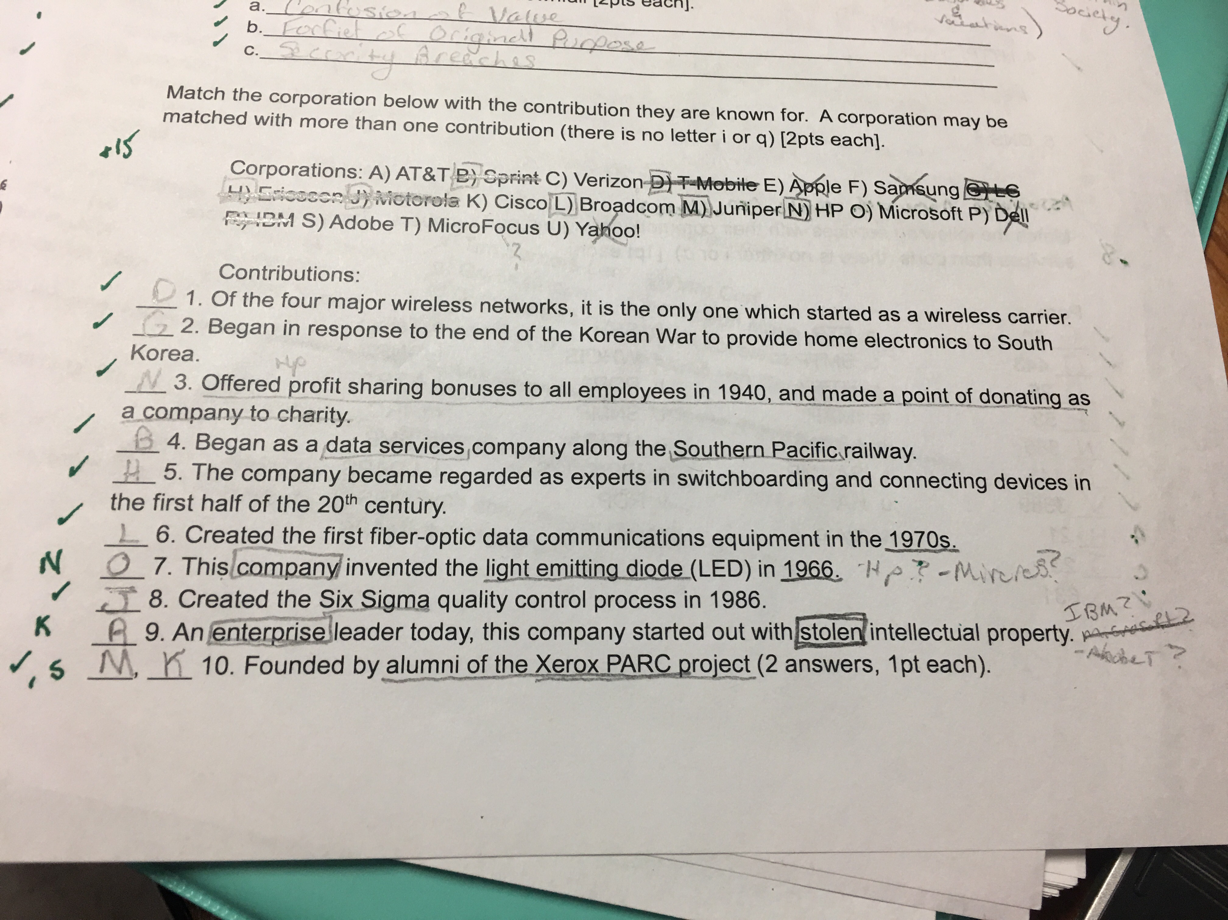

**9. GNU Tools**

**Posix 1-**

**Posix 2- specific**

**a. Basic Linux commands (type “man “ and the command name in Google to get the instruction page for the command):**

**i. Ls [-l]**

**ii. Tail [-f]**

**iii. Cat**

**iv. Vi**

**v. Chmod**

**vi. Grep**

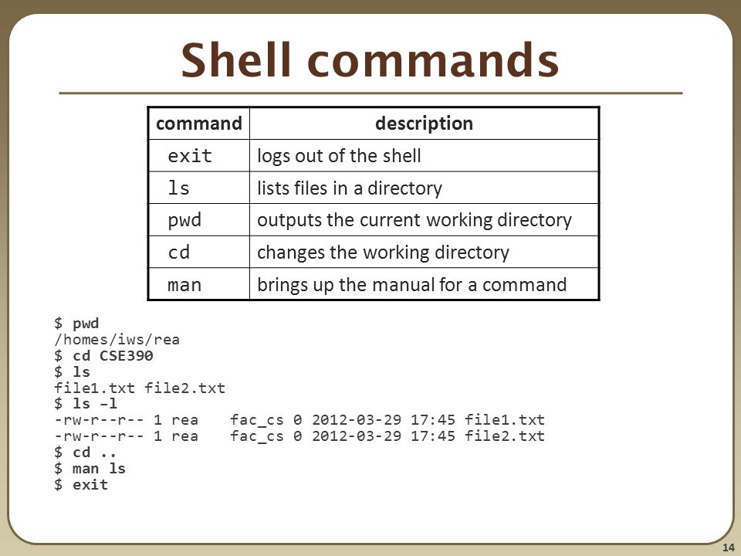

**b. Redirection (>, <, 2>, |)**

**10. Electronics**

**a. Ohm’s Law (E=IR, P=IE)**

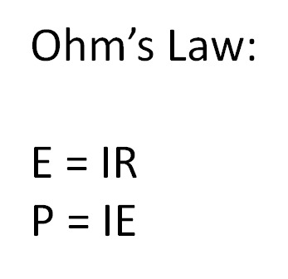

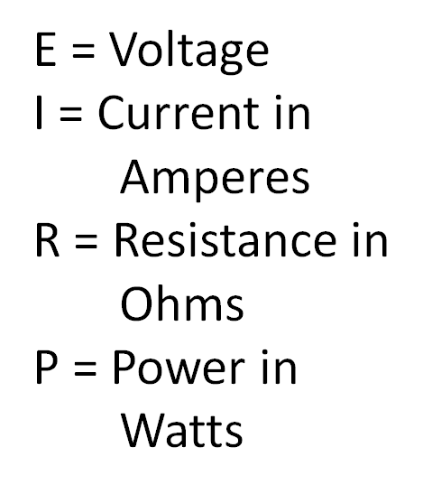

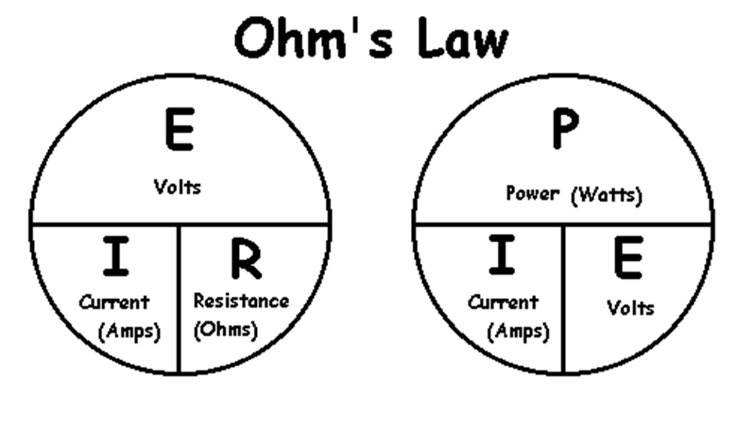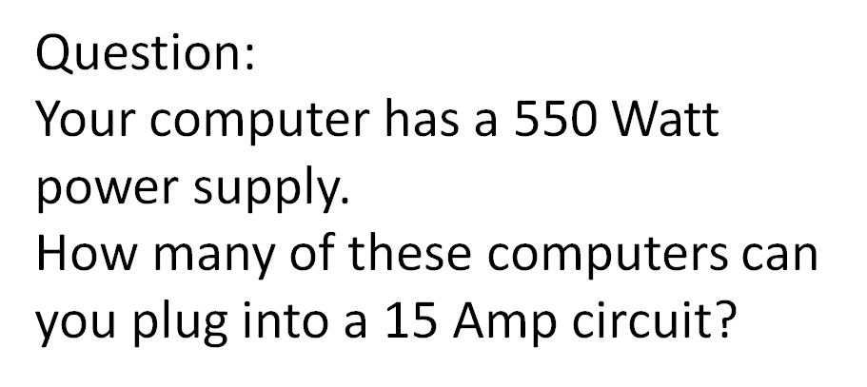

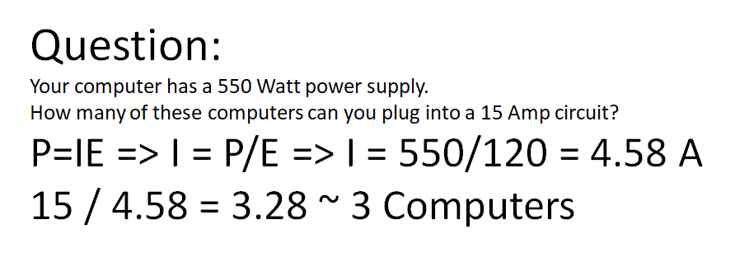

**b. Purpose of basic components: transistor, resistor, capacitor, diode**

**Transistor=** It can amplify and switch electrical power and electronic signals. Transistors are made of semiconductor material with three or more terminals used to connect to an external circuit. By applying a current or a voltage to one of the pairs of the terminals, there is a change in current through another pair of terminals.

Resistor= The main **function** of **resistors** in a circuit is to control the flow of current to other components. Take an LED (light) for example. If too much current flows through an LED it is destroyed. So a **resistor** is used to limit the current.

Capacitor= Its **function** is to store the electrical energy and give this energy again to the circuit when necessary. In other words, it charges and discharges the electric charge stored in it. Besides this, the **functions** of a **capacitor** are as follows: It blocks the flow of DC and permits the flow of AC

Diode= Main functions. The most common function of a diode is to allow an electric current to pass in one direction (called the diode's forward direction), while blocking it in the opposite direction (the reverse direction).

**c. Types of circuits (flip-flop, counter, binary coded decimal)**

**Flip-flop=**In electronics, a flip-flop or latch is a circuit that has two stable states and can be used to store state information. A flip-flop is a bistable multivibrator. The circuit can be made to change state by signals applied to one or more control inputs and will have one or two outputs.

**Counter=** In synchronous counters, the clock inputs of all the flip-flops are connected together and are triggered by the input pulses. Thus, all the flip-flops change state simultaneously (in parallel). The circuit below is a 4-bit synchronous counter. The J and K inputs of FF0 are connected to HIGH.

**Binary Coded Decimal=** Binary Coded Decimal or BCD as it is more commonly called, is another process for converting decimal numbers into their binary equivalents. As we have seen in this Binary Numbers section of tutorials, there are many different binary codes used in digital and electronic circuits, each with its own specific use.

**d. Logic gates: AND, OR, NOT, NAND, NOR, XOR**

